WD Diploma - Capstone Project

**Project Title:** *FARVEIW*

**Author:** Tennessee Bennett

**Cohort:** *Winter 2021*

Project Overview

### 1.1 Description

*FarVeiw is a react live web app that takes the info from nasas api and implements it in a Orrery.*

### 1.2 Problem

### Where do you go to learn about space and see the effects of gravity on our solar system? FarVeiw that’s where, when fully finished it will be the only Orrery available with planet scaling and custom situations.

### 1.3 User Profile

### This program is designed with students and teachers and content creators in mind, and as such will be easy to access for all ages and stages of learning.

### 1.5 Tech Stack and APIs

## Three.js, react-three-fibre, react, node.js, express.js, tensorflow.js, tycho.io/Scripts For Telnet connection.

## 2. Client-Side Implementation

### Site Map

*Main Orrery*

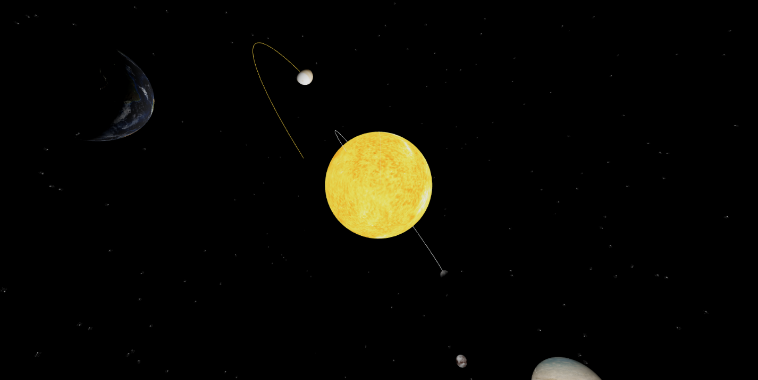

## 3. Server-Side Implementation

### 3.1 End-Point Descriptions

*A list of endpoints your server will implement, HTTP methods for the end points, and any parameters that the endpoint will accept to fulfill the request. e.g.:*

|  |  |
| --- | --- |
| **End-point** | **Response Format** |
| *HTTP GET - /planets* | **{**"planets": **[{**"x": **[0.004502508845301258**,**0.0007670734814646406**,**0.0002660563278120356]**,"v": **[-3.5174423541454e-7**,**0.00000517762777222281**,**0.00000222910220557907]**,"m": **1**,"r": **0.004654692513368984**,"color": "#e4e80e","name": "Sun","map": "models/sun.glb","info":"” |
| *HTTP GET - /Objects* | “Same as above” |

### 3.2 External APIs that will be consumed

Nasa SSD from JPL Labs

## 4. Project Roadmap

### Phase 1

Make planets spin, make them orbit sun, add skybox, meshs, Textures. On the back end server, we have the telnet system that needs to make a request every time the server starts and also once per 24 hours so it can grab the data from the JPL/NASA server without hitting my limit.

### Phase 2

*Rebuild the math conversion and rebuild the orbit simulator after I brush up on my calculus*

Make the camera follow planets, add dwarf planets, moons and spacecraft, add atmosphere and ground lvl for planets, add control panel to control scaling, speed, and INDIVIDUAL PLANET SIZE WEIGHT AND VELOCITY.

Also want to add sessioning and JWT tokens to be able to save custom planet settings

### Phase 3

Continue working on and perfecting this project